
Implementation Manual

Implementation Manual
The implementation manual contains the system configuration recommended to conduct the course. It also includes the steps to install JDK 6 and NetBeans IDE 6.0.1 on Windows platform.

Recommended System Configuration
The following table lists the recommended system configuration for the MR and CR sessions.

# | TYPE | MR | CR
1 | Number of Machines
1.1 | Faculty Node | NA | 1
1.2 | Student Nodes | <Depends on the machine room setup> | NA
2 | H/w Configuration
2.1 | Faculty Node | NA | A node with PIII processor (800 MHz or higher), 20 GB SCSI Hard disk, 512MB RAM, CDROM and 2-10/100 Mbps network cards.  VGA: 800x600 or higher
2.2 | Student Nodes | A node with PIII processor (800 MHz or higher), SCSI Hard disk of 20GB, 256MB RAM, CDROM and  1-10/100 Mbps network card. | NA
2.3 | Printer | NA | NA
3 | S/w Configuration
3.1 | First Faculty Node | NA | Windows XP with SP2, JDK 6 with NetBeans 6.0.1, MS Office 2007
3.3 | Student Nodes | Windows XP with SP2, JDK 6 with NetBeans 6.0.1, MS Office 2007 | NA
4 | Network Configuration | TCP/IP | TCP/IP
The Recommended System Configuration

Installing JDK 6 on Windows XP
To install the JDK 6 on Windows XP, you need to perform the following steps:
- Copy the jdk-6-windows-i586 file from the SUPPORT_SOFTWARE folder to your computer.
- Double-click the jdk-6-windows-i586 file to execute it. The Java(TM) SE Development Kit 6 wizard is displayed, as shown in the following figure.
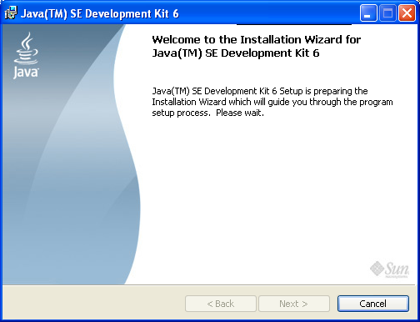
The Java (TM) SE Development Kit 6 Wizard

The control automatically moves to the License Agreement page, as shown in the following figure.
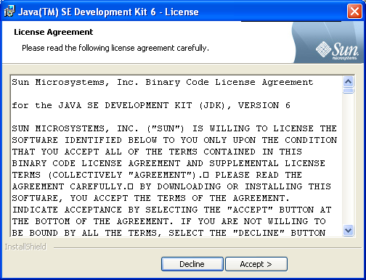
The License Agreement Page
- Click the Accept button. The Custom Setup page is displayed for installing Java(TM) SE Development Kit 6, as shown in the following figure.
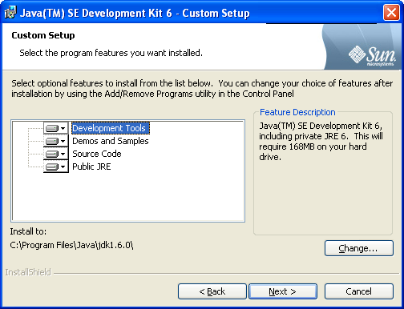
The Custom Setup Page

- Click the Next button. The Installing page is displayed, as shown in the following figure.
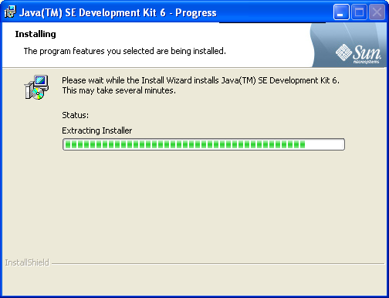
The Installing Page
After installing Java™ SE Development Kit 6, the control automatically moves to the Custom Setup page to install Java(TM) SE Runtime Environment, as shown in the following figure.
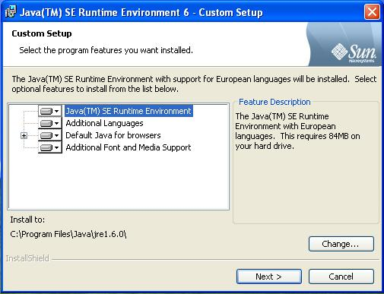
The Custom Setup Page
- Click the Next button. The Installing page is displayed, as shown in the following figure.
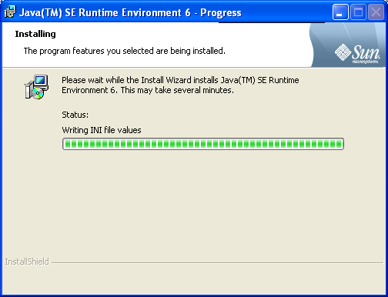
The Installing Page
After the installation is completed, the Wizard Completed page is displayed, as shown in the following figure.
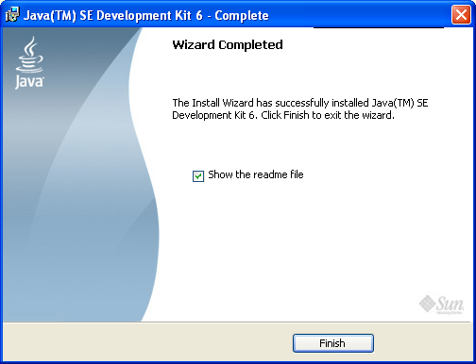
The Wizard Completed Page
- Click the Finish button. The JDK 6 has been installed successfully. The README window is opened in your default Web browser, as shown in the following figure.
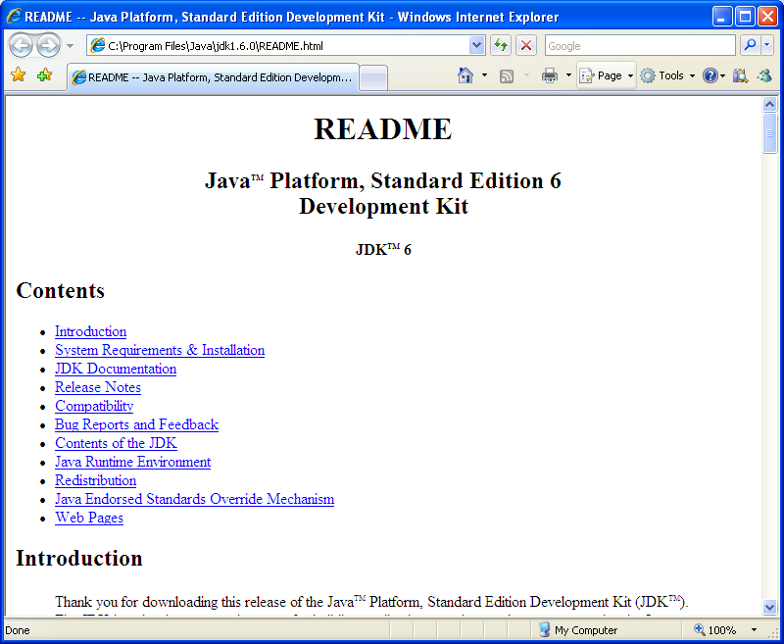
The README Window
- Close the Web browser.

Installing NetBeans IDE 6.0.1 on Windows XP

To install NetBeans IDE 6.0.1, you need to perform the following steps:
- Copy the netbeans-6.0.1-ml-windows file from the SUPPORT_SOFTWARE folder to your computer.
- Double-click the netbeans-6.0.1-ml-windows file to install it. The NetBeans IDE Installer wizard is displayed, as shown in the following figure.
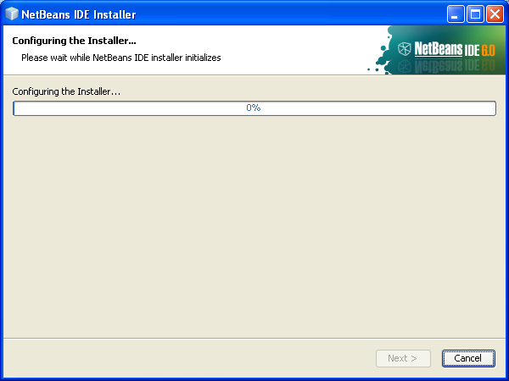
The NetBeans IDE Installer Wizard
The control automatically moves to the Welcome to the NetBeans IDE 6.0.1 Installer page, as shown in the following figure.
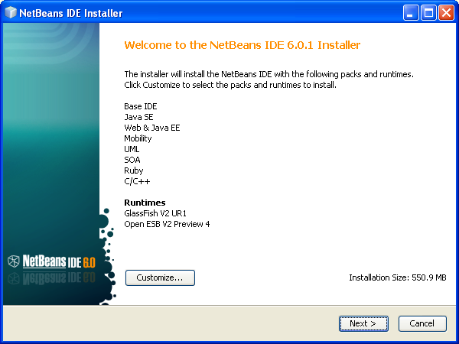
The Welcome to the NetBeans IDE 6.0.1 Installer Page
- Click the Next button. The License Agreement page is displayed, as shown in the following figure.
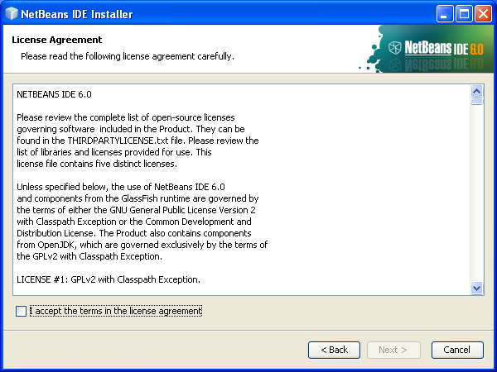
The License Agreement Page
- Select the I accept the terms in the license agreement checkbox and click the Next button. The NetBeans IDE 6.0.1 Installation page is displayed, as shown in the following figure.
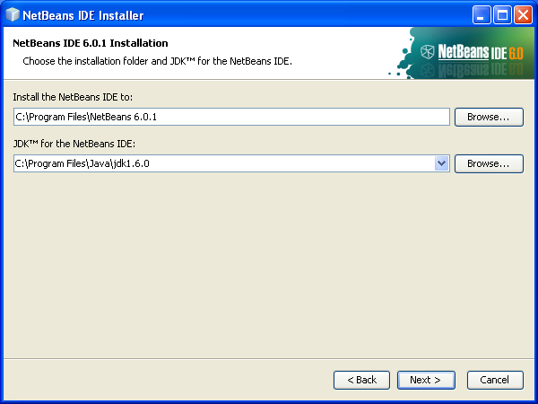
The NetBeans IDE 6.0.1 Installation Page

Note

You may browse and specify the different installation location or accept the default location.

- Click the Next button. The GlassFish V2 UR1 Installation page is displayed, as shown in the following figure.
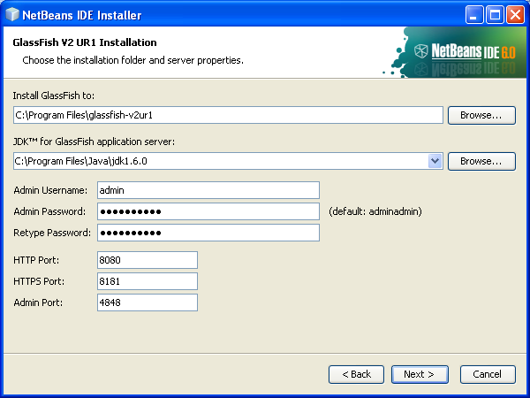
The GlassFish V2 UR1 Installation Page
Note
During the installation, the Windows Security Alert dialog box may appear if Windows firewall has blocked some features of the installation. Click the Unblock button to allow access to the blocked features of the installation.

- Click the Next button. The Summary page is displayed, as shown in the following figure.
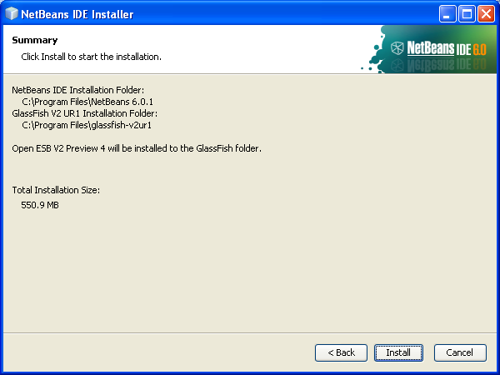
The Summary Page
- Click the Install button. The Preparing Installation Data… page is displayed, as shown in the following figure.
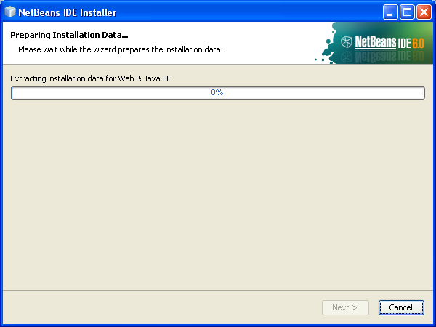
The Preparing Installation Data… Page
After the installation is completed, the Setup Complete page is displayed, as shown in the following figure.
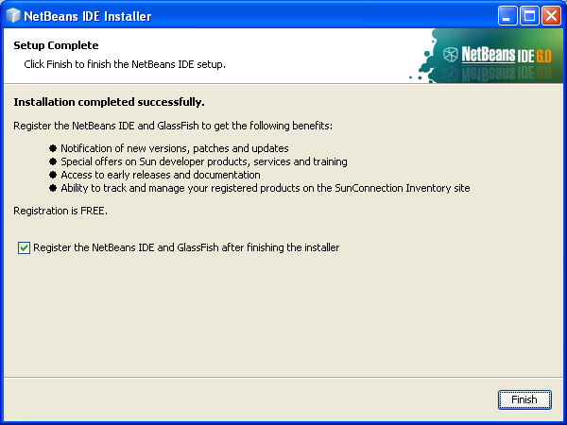
The Setup Complete Page
- Ensure that the Register the NetBeans IDE and GlassFish after finishing the installer checkbox is cleared.
- Click the Finish button.
Note
You can refer to Book3: Tool Reference for the working of the NetBeans IDE.

